Chile: The challenges towards the implementation of UNCAC

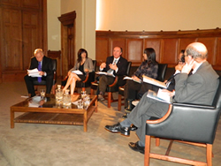
The book “Second International Forum: The Challenges for UNCAC implementation in Chile” was recently launched in Chile as part of the cooperation project between the General Comptrollership´s Office (CGR) and the UNDP Country Office: “Strengthening transparency and probity in public management through international cooperation and monitoring of UNCAC”.
The book summarizes the discussion that has taken place in Chile and globally regarding the challenges towards the implementation of UNCAC. The publication presents the contribution of more than 20 national and international experts from governmental institutions, cooperation agencies and anti-corruption agencies that gathered for the forum in Santiago in 2010, highlighting lessons learned, threats and challenges towards the implementation of UNCAC in Chile. The forum focused on issues such as the building of effective corruption indicators, securing corruption prosecution and sanction, the development of asset recovery mechanisms and strengthening transparency in the public and private sector.
The launching was jointly organized by the CGR, UNDP and the Catholic University of Chile. Among the commentators were the Minister of the General Secretary of the Presidency, Member of Congress, and renowned academics.

